**CS390S Assignment 3 (10 points)**

**Requirements:**

1. **Download face images “face_good.bmp” and “face_dark.bmp” from blackboard. Download function code “colorspace.m” for different color space conversion. Python users please check** *skimage.color.convert_colorspace()*
2. **Perform skin detection on both images using the skin detection method introduced in the paper “0REF_Paper_Survey on Skin Color Techniques”.**

**Reference Code:**

*ims1 = (im(:,:,1)>95) & (im(:,:,2)>40) & (im(:,:,3)>20);*

*ims2 = (im(:,:,1)-im(:,:,2)>15) | (im(:,:,1)-im(:,:,3)>15);*

*ims3 = (im(:,:,1)-im(:,:,2)>15) & (im(:,:,1)>im(:,:,3));*

*ims = ims1 & ims2 & ims3;*

**Python version:**

def skin_detect(im):

# Split RGB values

R,G,B = [im[:,:, channel] for channel in range(3)]

# Check if diff betw R and G is greater than lum 15

r_minus_g_gt_15 = np.abs(R.astype(np.int8) -G.astype(np.int8)) > 15

# Is there more R than B?

more_R_than_B = (R > B)

is_skin = ((R > 96) & (G > 41) & (B > 21) &

(im.ptp(axis=-1) > 15) &

r_minus_g_gt_15 &

(R > G) &

more_R_than_B)

return is_skin

1. **Remove the large false-positive area detected from the “face_dark” image.**

**Clearly describe how you removed the large false positive part in your report.**

*Suggested approach (not required):*

*The “face_dark.bmp” image contains large background region with extremely high luminance. Performing histogram analysis(Figure1) of the luminance component, setting a threshold* ***automatically*** *based on the histogram shape could help to delete the background area.*



Figure1. Histogram of the luminance component

Hard-coded threshold values are NOT allowed in your code.

1. **Show the detection results in your report, keep detected skin of the original image and mask out everything else. The final detection results with tiny/small noisy features (that are not skin such as following figure) are accepted.**

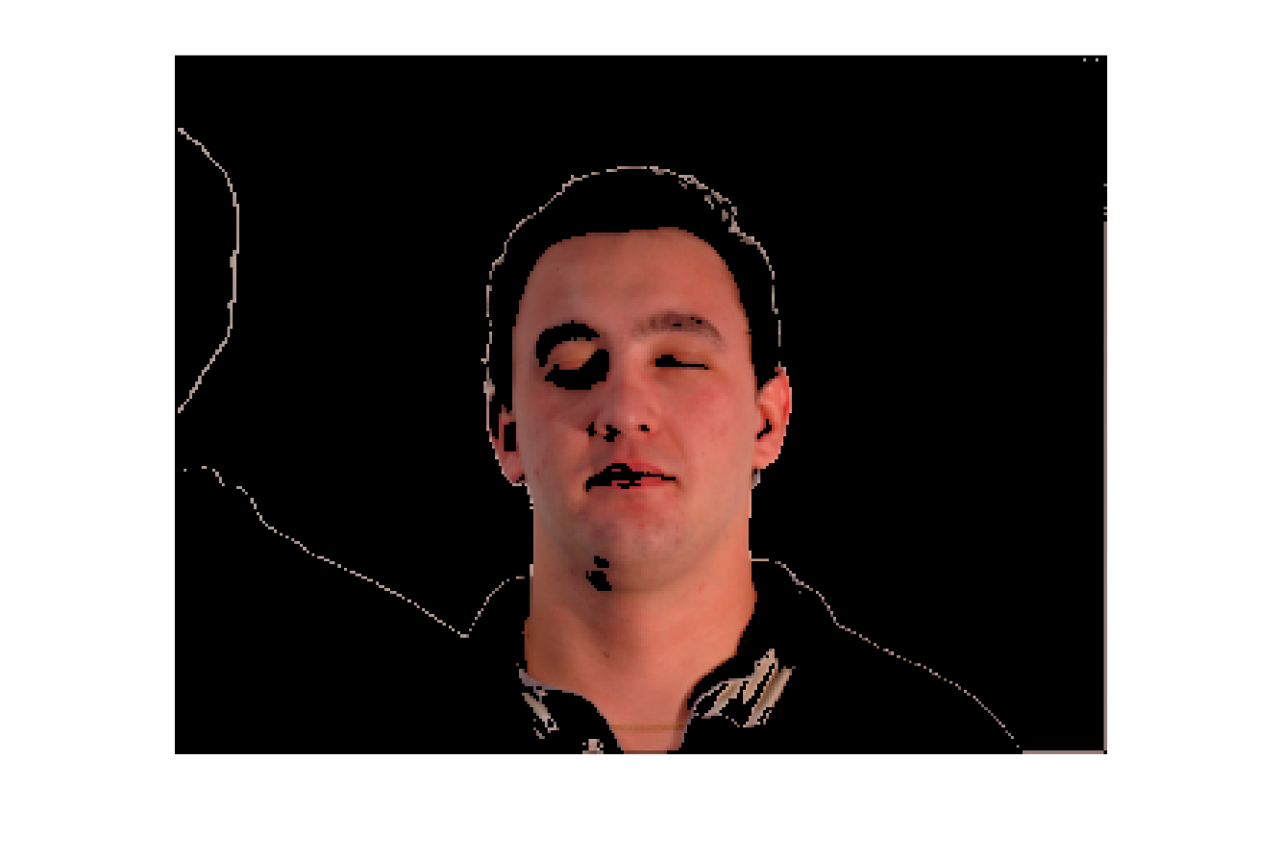

Figure2. Skin Detection Result

Functions that perform skin detection or face detection in one step are NOT accepted.

**What to submit:**

1. **Your report “Firstname_Lastname_HW3.docx/doc” or “Firstname_Lastname_HW3.pdf”**

In your report, please always include the input and output images and a brief discussion of your design or explanation of your code.

1. **A compressed “.zip” file** (**NO** “.rar” files accepted) including all the source code files and source images, output images, “read me” file or other support files to run your code.

* Students using Python need clearly specify what libraries are used in your report (and “imported” in your .py code files).
* Python source code must be submitted using “.py” extension (“.ipynb” files are not accepted).
* Image path in the source code must be relative path (e.g. “./iris.bmp” or “./image/iris.bmp”). **Absolute input/output path such as “C:/image/iris.bmp” is NOT accepted.**
* Resubmissios are accepted only:

1. Draft version (80% work is done) is submitted before deadline.

2. Resubmission is submitted within one week after the deadline.